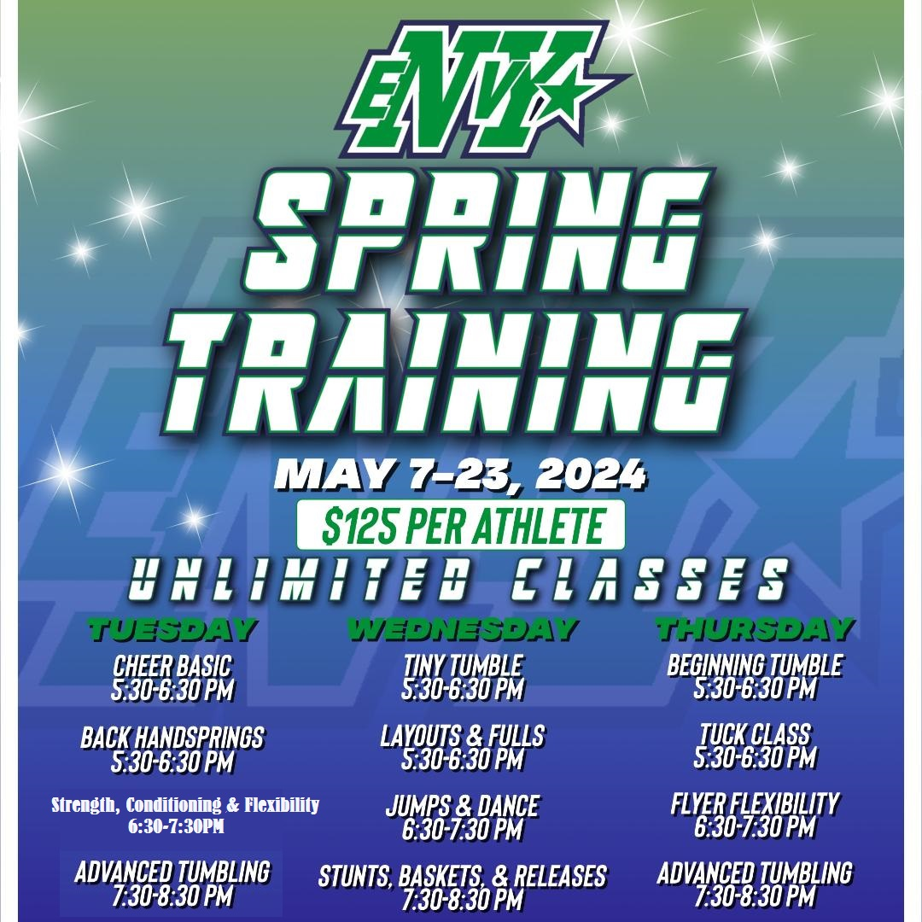
Class Descriptions:
Tiny Tumbling: This is a beginner class for athletes ages 3-6. The class is a wonderful place to learn the basic tumbling skills to build solid tumbling foundation. Athletes will learn hollow hops, skipping, front rolls, candle sticks, levers, bridges and more. This class will allow little ones to have fun time learning basic cheer tumbling.
Ages 7& older
Cheer Basic: Cheer basics is for all beginner athletes that are interested in trying cheer. Athletes will learn basic motions, different jumps, jump approaches and jump landings. They will also learn the basics stunting techniques and cheerleading lingo. This is truly for anyone that is looking to start their cheer journey.
Beginning Tumbling: This class is for athletes that are looking to start working Handstands, Hurdles, Cartwheels, Round offs, back walk overs, front walk overs. Athletes will be learning the proper start and finish to tumbling. Athletes will learn drills that can be usedat home to help progress their tumbling too.
Back Handsprings: This class is for athletes that are ready to learn the proper skills and technique needed to learn a back handspring. Athletes must be able to perform a front and back walk-over unassisted to participate in the class. Athletes will learn to work on the tumble track, and other mats and equipment used to assist learning a back handspring. The class will work standing back handsprings and running back handspring combinations.
Layouts & Full's: This class is for athletes that can perform a running tuck pass without assistance. Athletes will focus on the proper hollow body shape needed to have proper layout and full technique. The class will also work on drills, to help an athlete learn the proper technique of twisting.
Tuck Class: This class is for athletes that are looking to learn standing or running tucks. Front tucks, back tucks. The class will work proper set and technique to work Round off handspring tucks, and standing tucks. The athlete must be able to perform round off handspring series without assistance.
Strength, Conditioning & Flexibility: This class is made to build the strength, flexibility and overall endurance needed to be a competitive cheerleader. Athletes will learn basic stretching techniques for tumbling and stunting. The class will improve your overall fitness and strength and teach you things to do while at home.
Jumps & Dance: This class will focus on the proper technique of jumping. From Approach, physical jump/lift, the proper jump picture. Where the arms and legs should be in the jump. We will also work dance. Different dance moves, seat rolls, and transitional elements and footwork needed to be a solid dancer. We will also work on the athletes’ performance side of the sport. How to show showmanship, and different ways to project yourself and engage the audience during a performance.
Flyer Flexibility: This class is for all different level flyers that are looking to be a flyer in the upcoming season. Athlete's will work on the body positions, proper ways to stretch their body positions to help develop the flexibility needed to be a successful flyer. Flyers will learn the importance of pushing off, speed stunts to the tops, and learn how to properly fall without hurting others.
Advanced Tumbling: A class focused on proper technique and fundamentals for standing and running tumbling past a tuck. All athletes must have an unspotted running tuck to attend. We will work, layouts, Full's, double Fulls, front through and Arabian specialty tumbling passes. Athletes will learn the proper take off for a double full too.
Stunts, Baskets & Releases: A class that will teach bases and flyers the proper technique and safety for stunts, release skills and basket tosses. Athletes will learn proper basket toss grips. Proper cradle technique, and a variety of release moves in stunts.

